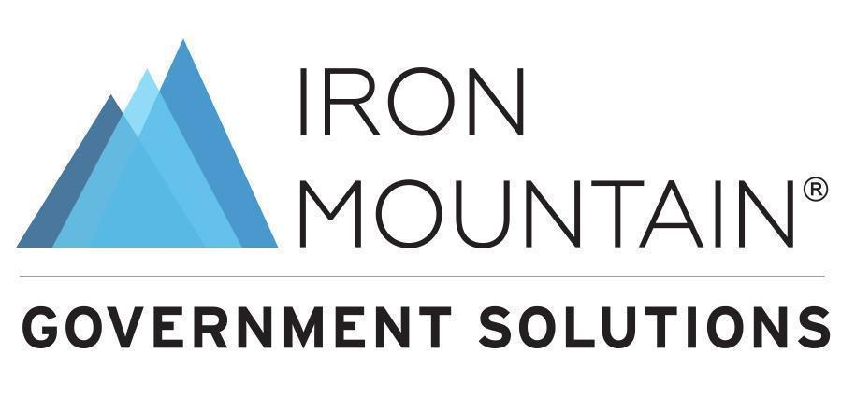

Contact:
Kristen Keller
Director, Public Sector Marketing
810.543.5325
kristen.keller@ironmountain.com

Iron Mountain to Partner with the U.S. Government Publishing Office in Support of the Defense Logistics Agency’s Strategic Content Digitization Initiative

On-Site and Off-Site Digitization Contracts awarded to drive conversion and digital transformation to empower modernization across the Department of Defense

HERNDON, VA–8/14/24–Iron Mountain Incorporated ® (NYSE:IRM), the global leader in innovative information management services, today announced it has been named by the U.S. Government Publishing Office (GPO) as the awardee of both off-site and on-site contracts for strategic conversion and document digitization efforts. Under these contracts, Iron Mountain’s work supports the U.S. Defense Logistics Agency’s (DLA) ongoing modernization initiatives by creating a robust digital foundation that provides greater visibility, accuracy, and speed for the Department of Defense (DOD) across the supply chain and readiness operations.
These contracts are one base year and four additional one-year option periods and will establish Iron Mountain as an authorized provider of Intelligent Document Processing (IDP) for classified and unclassified documents in any analog format for DOD.
“Data is the lifeblood of DOD’s records strategy to deploy information for decision advantage and effective mission decision-making. DOD now has access to Iron Mountain’s InSight® IDP solution to jump-start unlocking valuable data trapped on analog records,” said Melissa Carson, VP & GM of Iron Mountain Government Solutions. “These contract awards represent DLA’s commitment to modernizing the department’s data foundation and ensuring critical information is digitized and delivered to all military branches at scale.”
To learn more about how Iron Mountain Government Solutions is supporting DLA and other defense agencies, please visit: https://www.ironmountain.com/industries/public-sector.
About Iron Mountain
Iron Mountain Incorporated (NYSE: IRM) is a global leader in information management services. Founded in 1951 and trusted by more than 240,000 customers worldwide, Iron Mountain serves to protect and elevate the power of our customers’ work. Through a range of services including digital transformation, data centers, secure records storage, information management, asset lifecycle management, secure destruction, and art storage and logistics, Iron Mountain helps businesses bring light to their dark data, enabling customers to unlock value and intelligence from their stored digital and physical assets at speed and with security, while helping them meet their environmental goals.
To learn more about Iron Mountain, please visit: www.IronMountain.com and follow @IronMountain on X (formerly Twitter) and LinkedIn.
About the Defense Logistics Agency: As the nation’s combat logistics support agency, DLA manages the end-to-end global defense supply chain – from raw materials to end user disposition – for the five military services, 11 combatant commands, other federal, state, and local agencies, partner and allied nations.
About the U.S. Government Publishing Office: GPO publishes trusted information for the Federal Government to the American people. The agency produces and distributes information products and services for all three branches of the Federal Government, including official publications of Congress, the White House, and other agencies in both digital and print formats. GPO’s print procurement program contracts with private section firms for nearly 78% of all printing and scanning ordered by Federal agencies from GPO.

