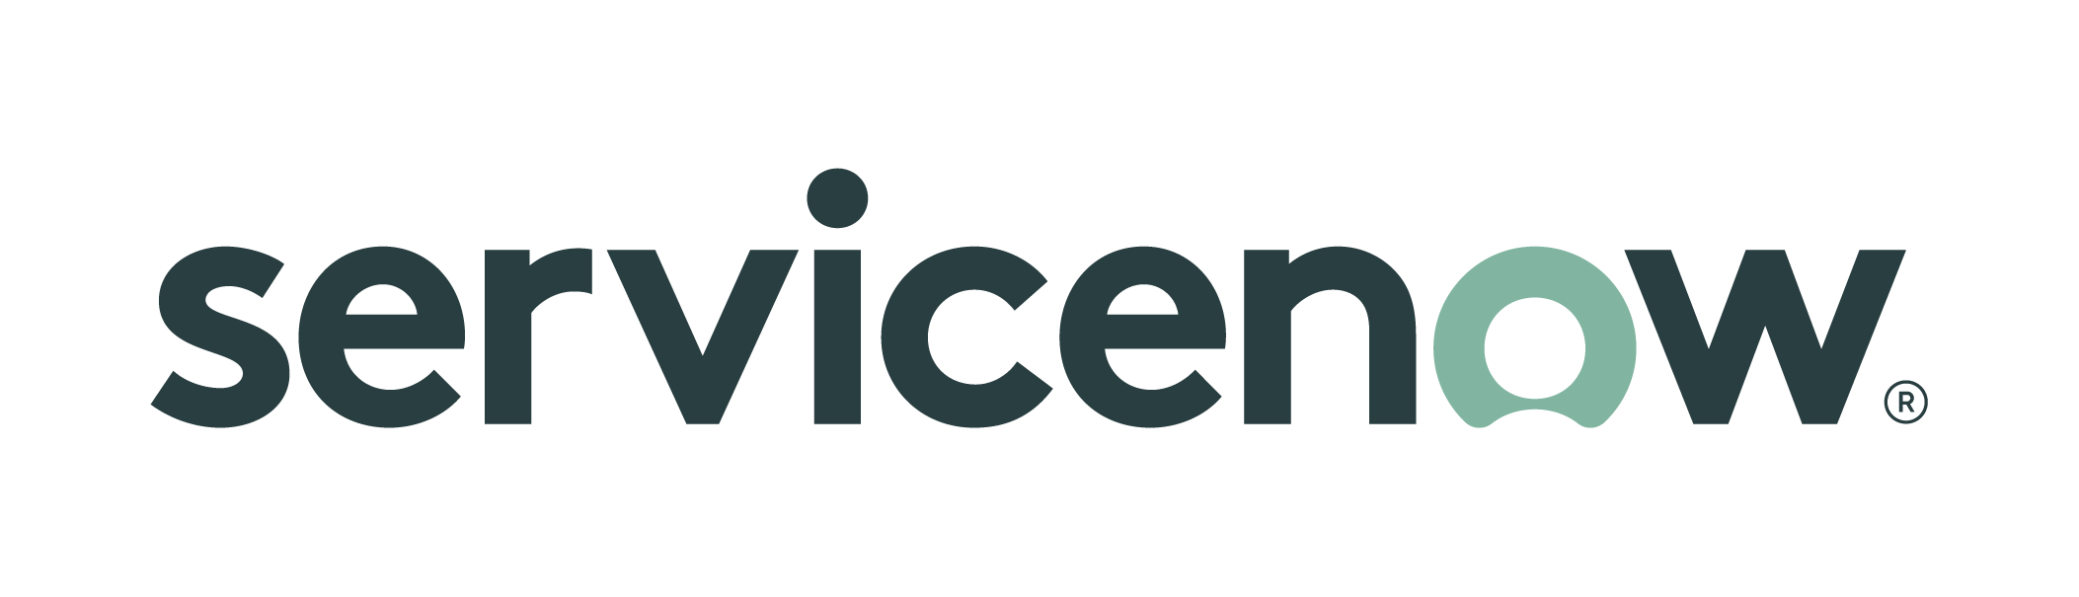**ServiceNow -** *We make the world of work, work better for people*

*ServiceNow has provided a platform to multiple NGA networks that defines, structures, and automates the workflow for mission, technical, and business applications to remove inefficient and manual processes to streamline the delivery of services, create great experiences and unlock productivity. NGA’s ServiceNow platform is just at the beginning of unlocking employee potential and speeding innovation. Beyond greatly enhancing IT service management, CMDB improvements and increased security capabilities, ServiceNow is eager to further fuel efficiency, productivity and innovation with capabilities surrounding; Low-Code / no code, AI/ML, workflows and integration tools enhancing systems of record ability to interact with each other and people, all making the world of work, work better for people.*

**Company Overview**

* ServiceNow was founded in 2004
* ICD-503 accredited with implementations at all the “Big 5” intelligence agencies and many of the Military Intel Components
* 75% of ServiceNow product portfolio deployed in production (recognized as the ITSM standard)
* TS/SCI Cleared Pre & Post Sales Resources & 24x7x365 US Based Support Center(s)
* 80% of Fortune 500 use ServiceNow & 98% Renewal Rate
* NGA started partnership with ServiceNow in 2017
* ServiceNow current capabilities at NGA – IT Service Management, IT Business Management, Discovery, SecOps, Business Continuity Management, Integrated Risk Management
* A leader in 2021 Gartner Magic Quadrant for IT Service Management Tools (8th consecutive year), CRM Customer Engagement Center, IT Vendor Risk Management Tools (2nd consecutive year), Enterprise Agile Planning Tools
* A leader in 2020 Gartner Magic Quadrant for Enterprise Low-Code Application Platforms, Software Asset Management Tools, IT Risk Management
* A leader in the Forrester Wave Value Stream Management – Q3 2020, Governance, Risk, and Compliance Platforms – Q1 2020, Enterprise Service Management – Q4 2019

**Brief Summary:**

ServiceNow can empower the NGA with:

* **Maximize the C2E cloud program.** Agencies are becoming more reliant on the cloud. Leverage ServiceNow to help automate, orchestrate, and manage on premises and multi-cloud infrastructures that allow users to update the CMDB and fully discover enterprise-wide assets.
* **Automate workflows across isolated systems, people, and applications.** Replace email and spreadsheet management and rigid legacy applications. Accelerate workflows by turning multi- step processes into automated workflows that can be audited, tracked, and reported.
* **Accelerate application development and expand developer base.** Leverage low code/no code capabilities to quickly and safely meet mission and business standards by empowering citizen development. We deliver these capabilities to create intuitive experiences while enabling cross-enterprise application delivery.
* **Hardware and software asset management.** Achieve better management and auditability for enterprise software and hardware assets. ServiceNow can help consolidate and integrate with our central system of record for IT. Our Configuration Management Database (CMDB) ensures more accurate representation and tracking of government assets.
* **Enhance cybersecurity Risk Management Frameworks (RMF).** Automating RMF with ServiceNow Continuous Authorization & Monitoring (CAM) allows automation of the RMF process and its associated tasks while reducing risk and decreasing time and effort in authorizing a system.
* **Data integrity** - Integrating data into one platform for a “single source of the truth” allows all data to be brought together and managed in one location.
* **Optimized reporting and business intelligence** - Powerful business intelligence and reporting technologies deliver complete visibility into the service performance of IT.

Please stop by our booth to discuss our capabilities in the following areas: Enable and empower workers as builders enabling their specific process knowledge to be digitized, Build with and by customers, Transform interaction with and across digital workspace, Integrate and enhance systems of record, leverage full potential of data, Supply chain and vendor management, multi cloud and on prem service and IT management, Risk management, AI/ML enhanced employee productivity, Security, DevSecOps, Low code/ no code, Requirements management, Test management, COVID and Health tracking and analysis, legal, policy and workplace process and knowledge digitization, enhance commercial cloud usage and ability to move and develop easily between networks.

**Visit us during GEOINT 2021 -** Booth #1612