**Alteryx**

Democratize your data, automate analytic processes, and cultivate a data-savvy workforce.

The Alteryx Analytic Platform accelerates data-driven business outcomes across lines of business in any industry. Organizations can develop faster results, deeper insights, better decisions, and ultimately create a cultural shift where anyone can drive business outcomes through self-service analytics and data science.

**Company Overview**

* **Stock Symbol** NYSE: AYX
* **IPO Date** March 24, 2017
* **Founding** 1997
* **2021 revenue:** $638 million, 30% yoy recurring revenue growth

**Brief Summary:**

Alteryx has a number of current customers within the US Federal Government ecosystem. Below represents just a sampling of the current customer base and uses cases where the Alteryx Analytics Platform is deployed.

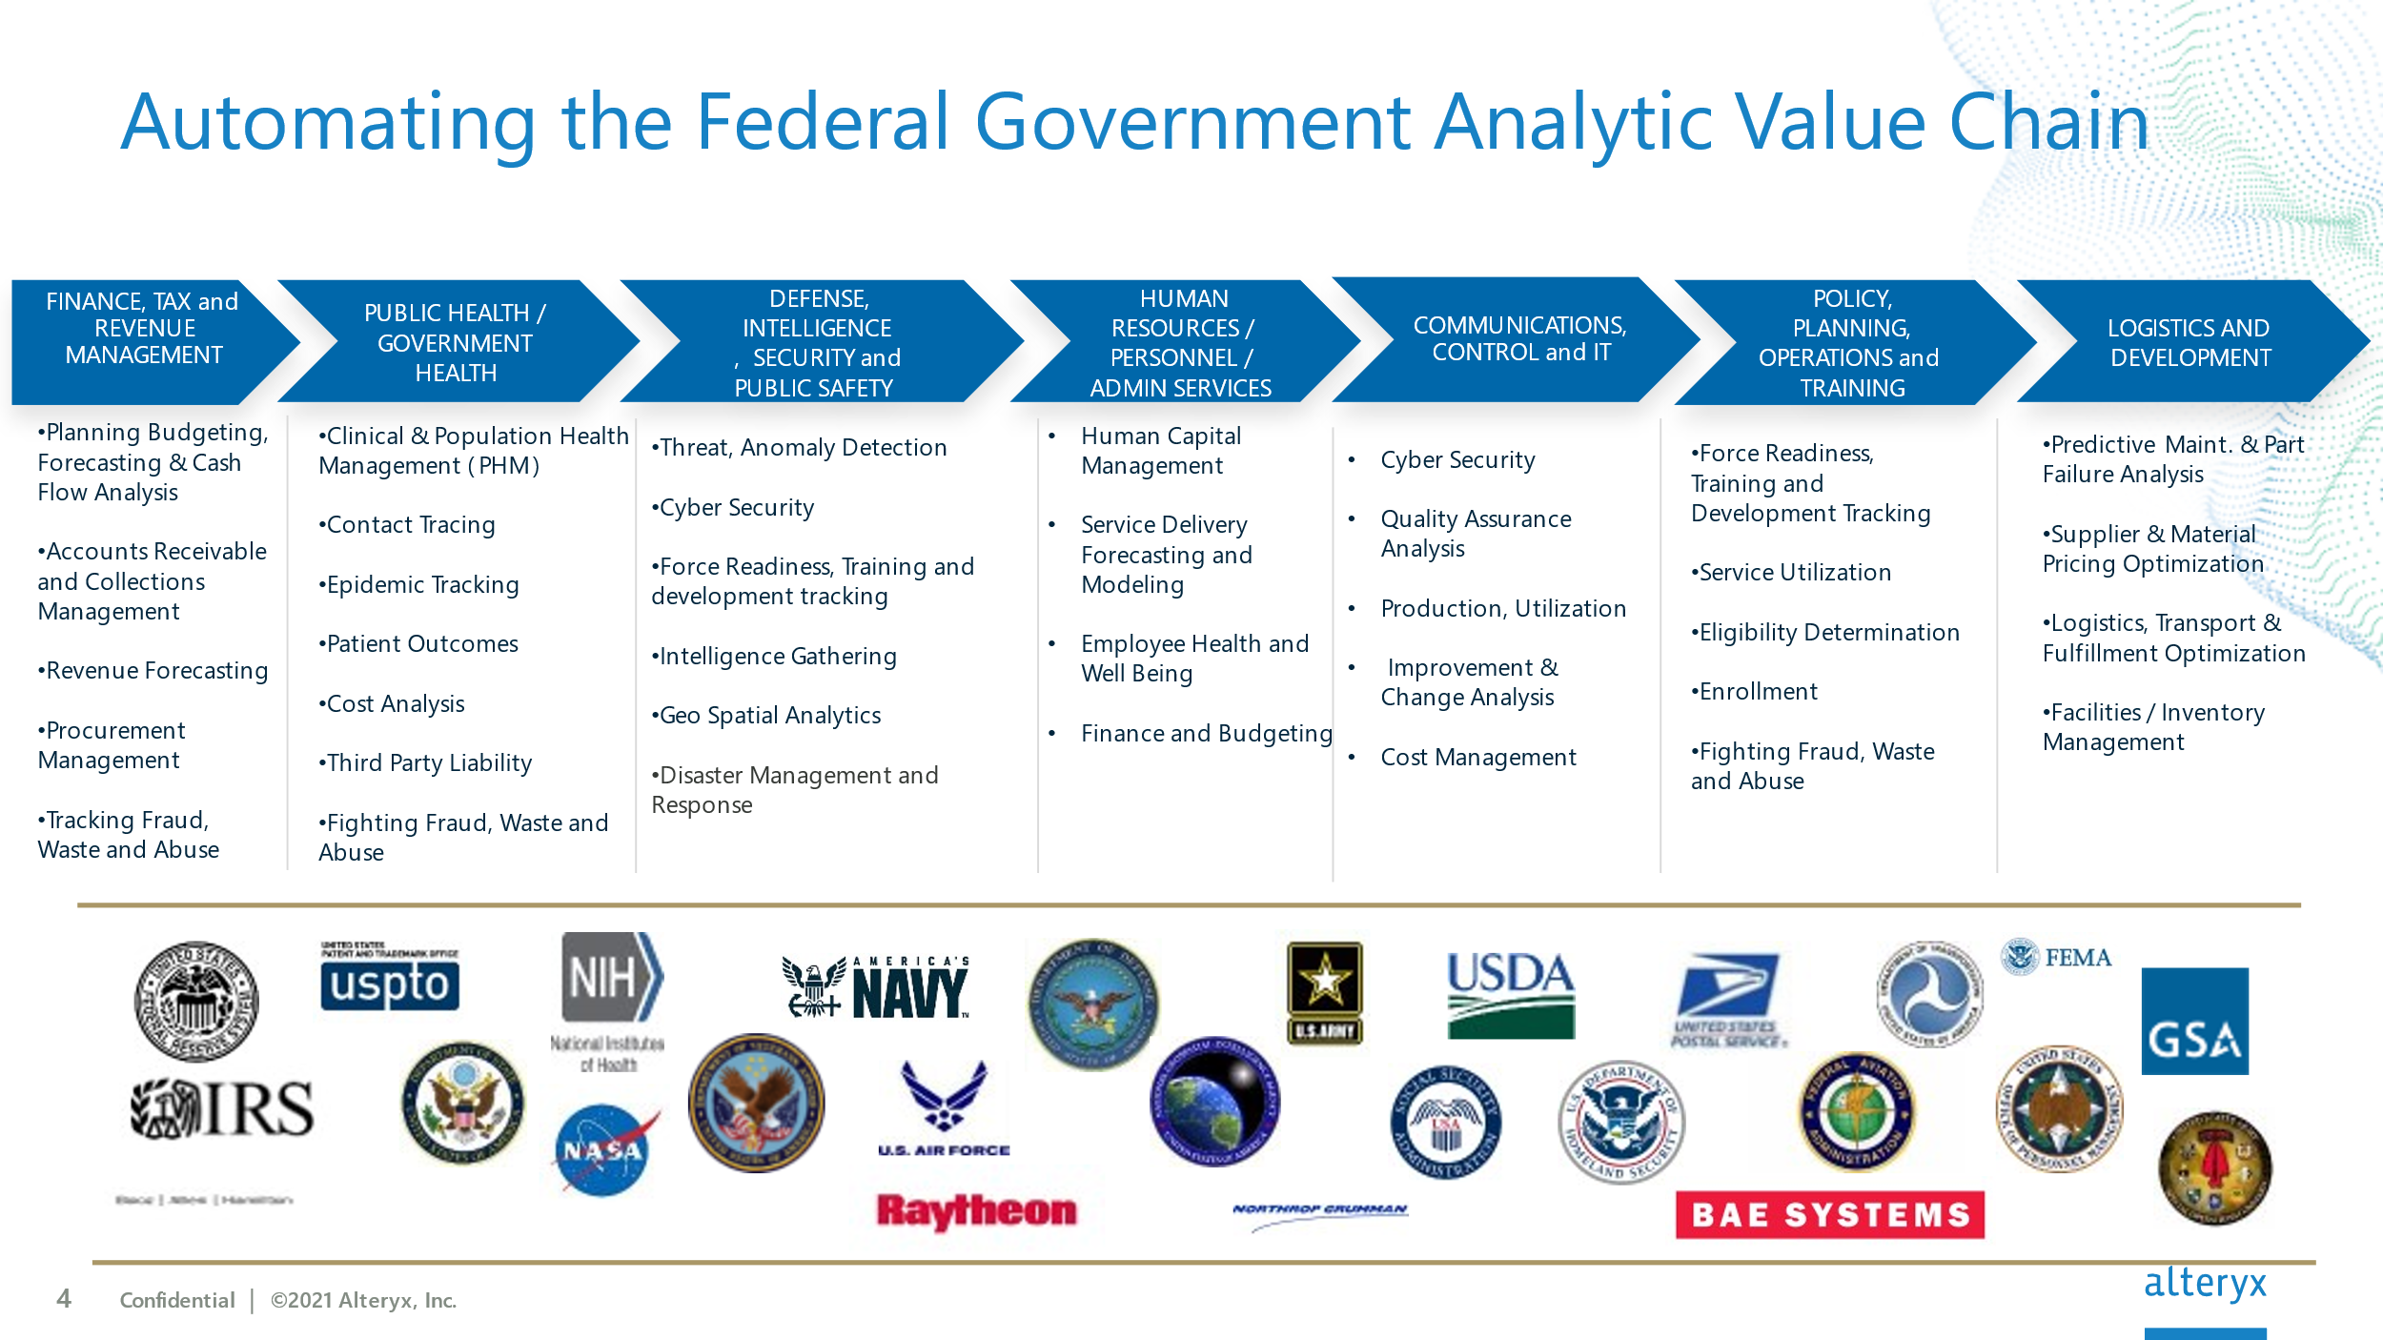

**As of February 2022, Trifacta is part of Alteryx.** With this acquisitionAlteryx intends to combine its leading low code/no code analytics solution with Trifacta’s cloud native capabilities to offer flexible deployment options — on-premises, hybrid and cloud — to meet enterprise customers’ analytics needs. Alteryx will also continue to invest in its Designer and Server products, providing customers with deployment flexibility for their analytic workloads whether on premises, hybrid or in the cloud.

**Relevant topics may include, but not limited to:**

Spatial Data Discovery

Future Workplace Technology

Supply Chain Management

Geospatial AI

Advanced Analytics Integrated BIM and GIS

Disaster and Risk Management

Analysis and Visualization

Model Web, Geospatial Workflows and Service Composition

Spatiotemporal Data Acquisition, Modelling, and Analysis

**Visit us during GEOINT 2021**

Booth #1405