*Veritas Technologies, LLC*

A new way to manage data

Veritas is uniquely equipped to help organizations of all sizes conquer the complexity of managing and protecting their business-critical data. Through our integrated product portfolio, we provide a unified data management experience that delivers unmatched performance and versatility—edge to core to cloud.

**Key Contacts & Contracts (if applicable):**

* Currently implemented at NGA supporting over 3Tb of data protection throughout NGA
* Key relationships with NGA, CIA and DIA and throughout the DOD and IC communities

**Company Overview**

* Veritas was founded in 1983 with its origins in Tolerant Systems.
* Veritas has helped guide enterprise customers through every disruptive technology shift of the past 30 years with an integrated approach to data management and protection.
* Significant NGA investment in data protection products
* Veritas is implemented throughout the Civilian, DOD and IC Government customer base. Veritas is also the data protection provider within many parts of State and Local Government and Healthcare. In the commercial space 93% of Fortune 100 and 87% of Global 500 companies use choose Veritas.

**Brief Summary:**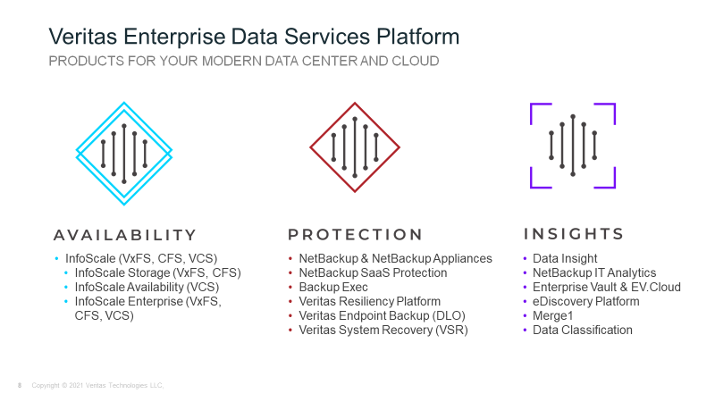

**Relevant topics may include, but not limited to:**

* Data Protection
* Operational Resiliency
* Archiving and Data Migration
* Data Compliance
* Hybrid/Multi-Cloud Computing
* Ransomware, Zero Trust
* Disaster and Risk Management
* Geospatial Data Management

**Visit us during GEOINT 2021**

Booth #1411